***ORGANIZATION EMPLOYEE DETAILS PROJECT***

***Description:***

*By Using of this project we can maintain the Employee details . We can insert and update the Employee details in database, using of cookies we can login the employee details.user details accessed by admin in the project.we also provide logout in the project*.

**Screenshots of the above project:**

**View Employee details:**

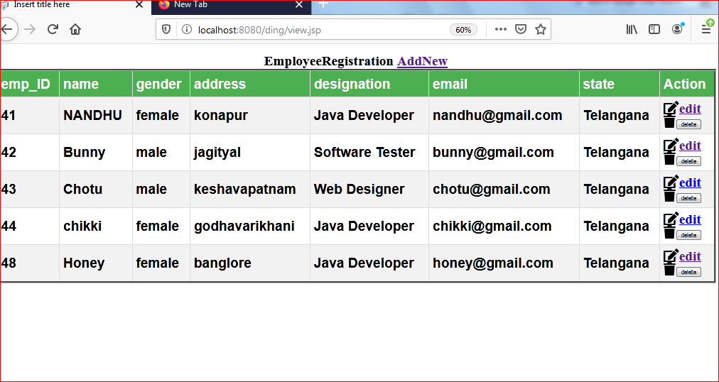

**Login page:**

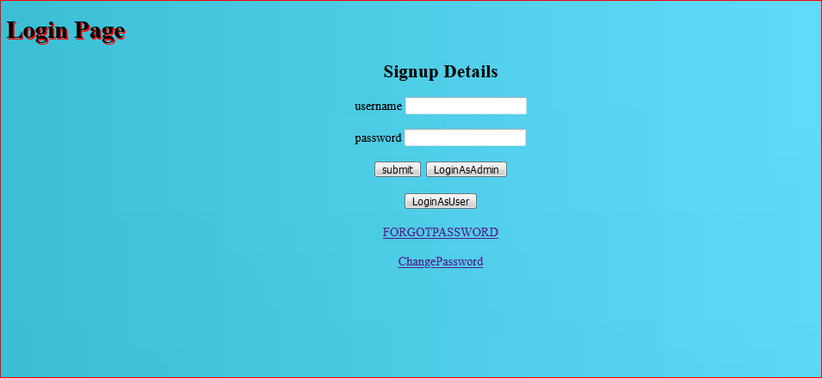

**Admin Page:**

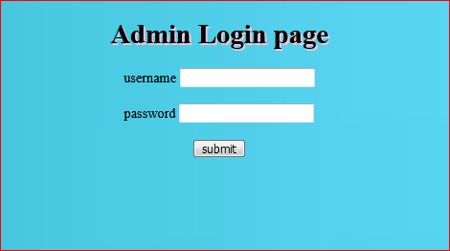

**Registration page:**

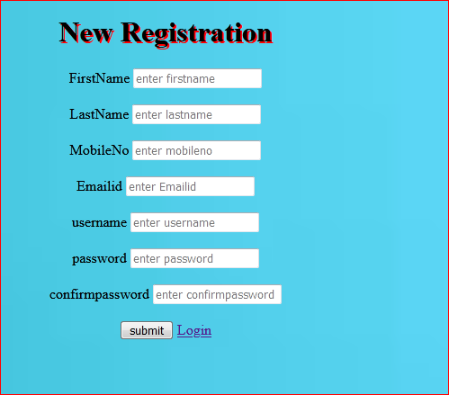

**Registration user details in database:**

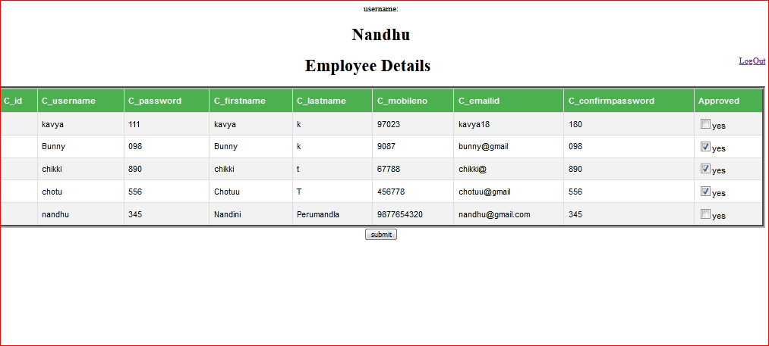

***Things I have used in project:***

***Servlets:***

* ***get parameter ( ):*** *in this we can write string value to get the paramters from the server.*
* ***equalsIgnoreCase( ):*** *compare two strings irrespective of the case*
* ***preparedStatement:****by using of preparedstatement we can insert parameters into the SQL statement*
* ***printwriter:****the method is receives the request and response output.*
* ***Resultset:****Resultset maintain a cursor that points to the current row in the table*
* ***Statement:****it used for accessing the database.*
* ***sendRedirect( ):*** *can be used to redirect response to another resource.*
* ***Cookies:*** *a cookie is a small piece of data stored on the client-side which servers use when communicating with clients. They're used to identify a client when sending a subsequent request. They can also be used for passing some data from one servlet to another*.

**JBOSS 7 :**

* Installation of JBOSS .
* Set the JBOSS locally.
* Project deployment.

**JDBC:**

* **Connection:** *represents a database connection to a relational database.*
* **Statement.**
* **Prepare Statement**
* **Result Set**
* **Before First( );** *the ResultSet interface moves the pointer of the current object to the default position, from the current position*
* ***rs.next( ):*** *the ResultSet interface moves the pointer of the current object to the next row, from the current position*
* ***ExecuteQuary( ):*** *Using of this method we can are INSERT , DELETE , or UPDATE SQL statements*.

**JSP SERVER:**

* ***Scriptlets tag :*** Scriptlet tag is used to execute java source code in jsp.

*<%java source%>*

* ***Expression tag :*** It is used to print the values of variable or method.

*<%=expression%>*

* ***Declaration tag :*** It is used to declare fields and methods*.*

*<% ! declaration var %>*

***MYSQL DATABASE:***

* Installation of mysql.
* Creating database
* Create table
* Truncate table
* Insert the values in table
* Primary key: Auto Increment
* Alter Table.
* Update table.

.

**I have get some exception in the Project:**

* ***ClassNotFoundException:*** To set the DriverManager .
* ***NullPointerException :*** To check and set the Null values.
* ***SQL Exceptions:***
* ***Connecting with JDBC driver class:***
* ***Illegal State Of Exception:*** *Java application is not in an appropriate state for the requested operation.*